cd Tutorial_Experiments

mvn compile

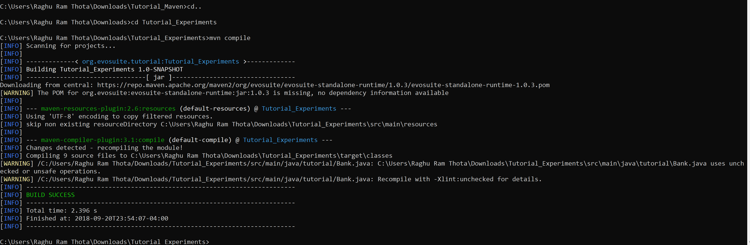

mvn dependency:copy-dependencies -DincludeScope=runtime

here there will be a error, change evosuite-standlone-runtime from 1.0.3 to 1.0.6 in pom.xml

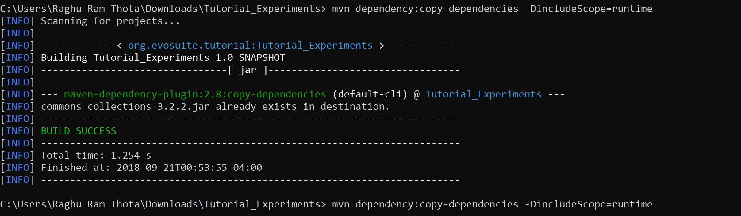

%EVOSUITE% -setup target/classes target/dependency/commons-collections-3.2.2.jar

Set again %EVOSUITE% and copy evouite1.0.6 jar file into tutorial experiments, otherwise not working.

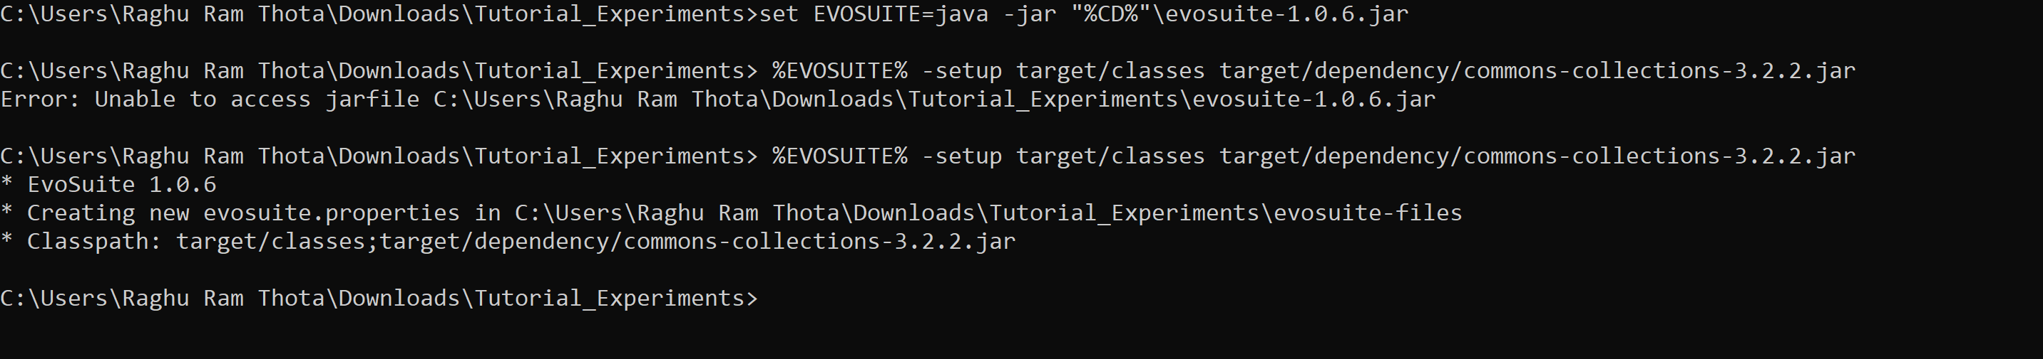

set CP=target/classes;target/dependency/commons-collections-3.2.2.jar

%EVOSUITE% -class tutorial.Person

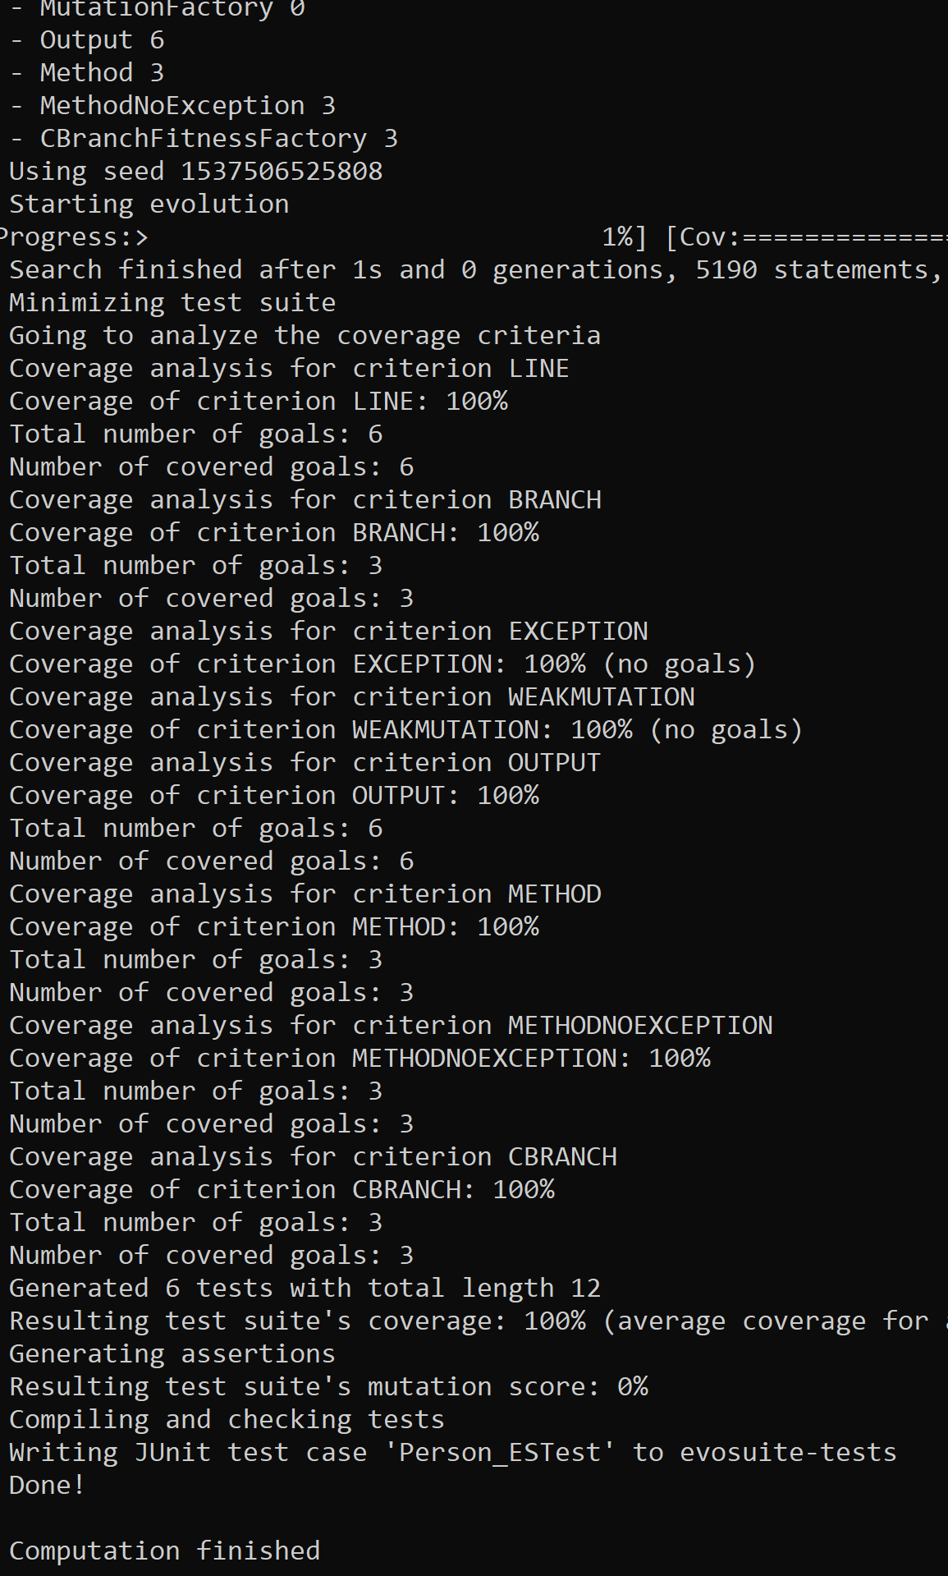

evosuite-report/statistics.csv(this is not command)

%EVOSUITE% -class tutorial.Person -criterion branch(don’t open statistics file, close it)

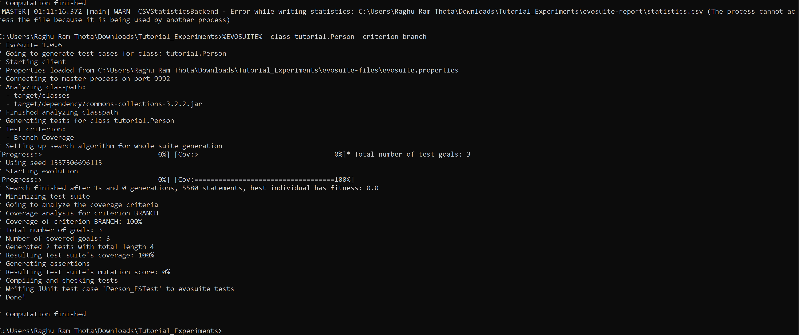

%EVOSUITE% -class tutorial.Person -criterion line

Same kind of output will come.

For next command to execute first remove statistics.csv

%EVOSUITE% -class tutorial.Company -criterion branch -Doutput_variables=TARGET_CLASS,criterion,Size,Length,MutationScore

Now you will see again statictics.csv in evosuite-reports

Now again remove statictics.csv

%EVOSUITE%-criterion branch -prefix tutorial -Doutput_variables=TARGET_CLASS,criterion,Size,Length,MutationScore

**Left for loops,python related**

%EVOSUITE% -class tutorial.ATM -criterion branch -Doutput_variables=TARGET_CLASS,BranchCoverage,CoverageTimeline -Dtimeline_interval=1000 -Dsearch_budget=30

